Module 03

Bai_01

Timeline + Gantt Chart

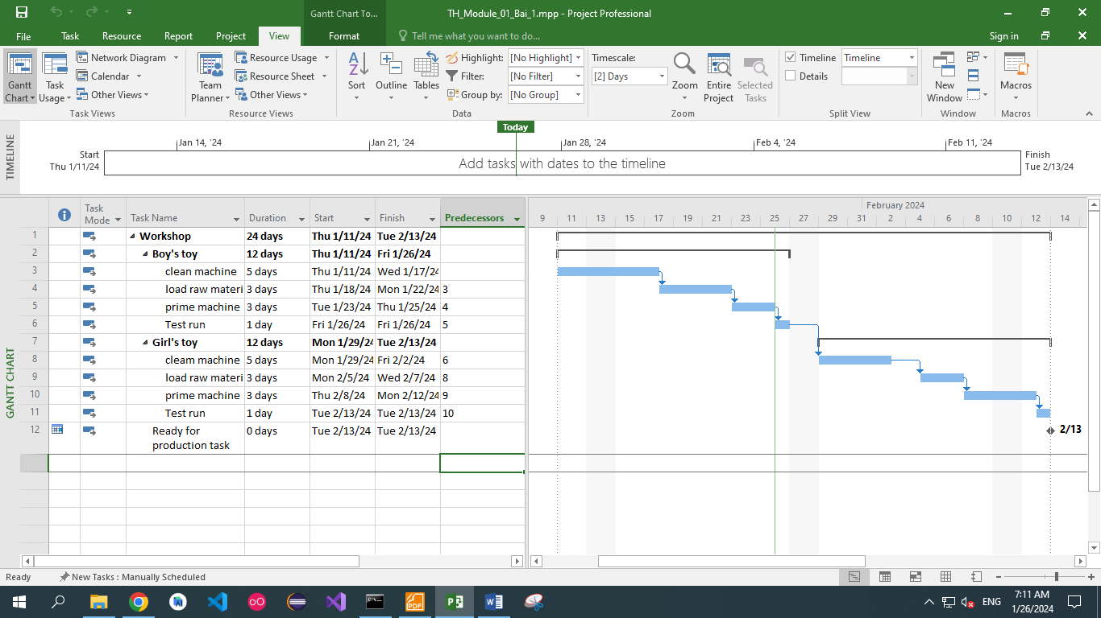

View CP + total Slack

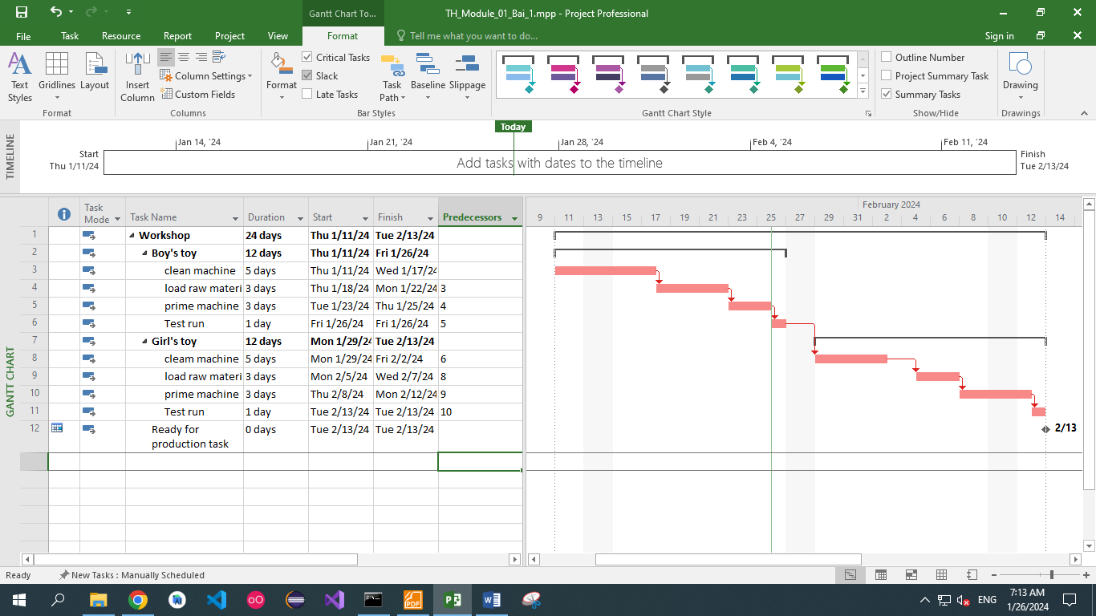

Bai_02

Timeline + Gantt Chart

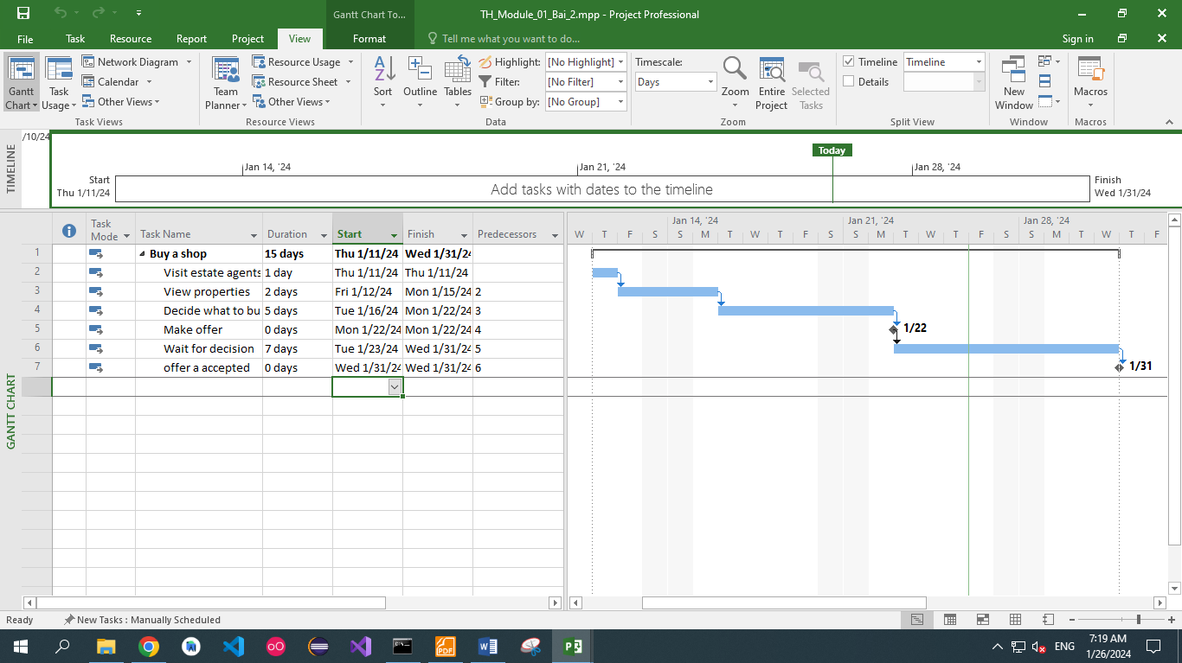

View CP + total Slack

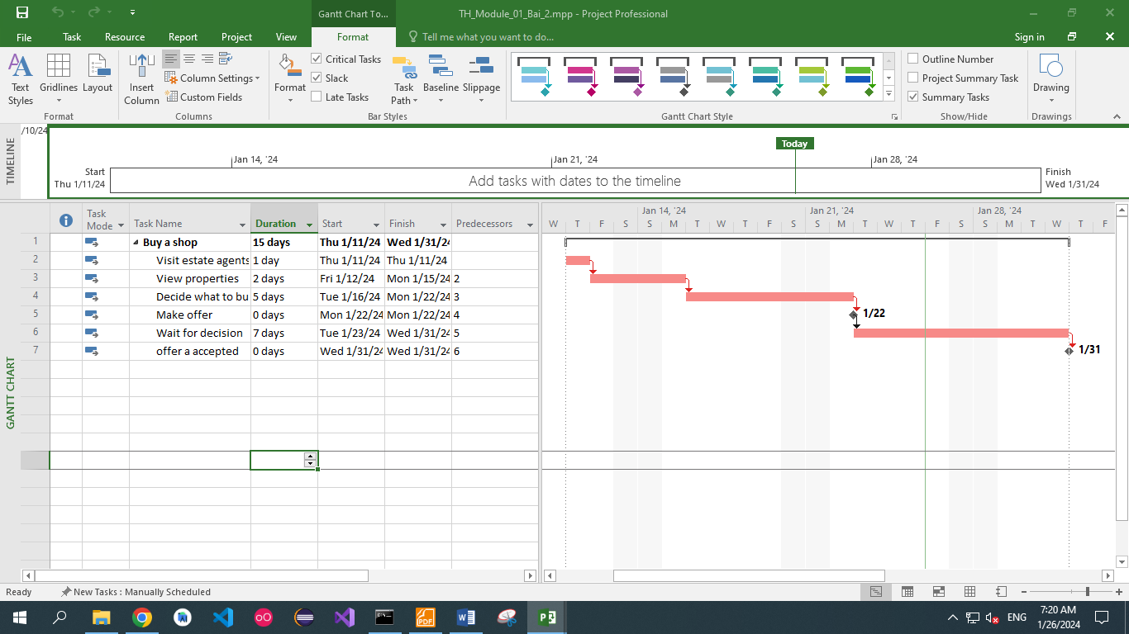

Bai_03

Gantt Chart + view CP + Project Slack

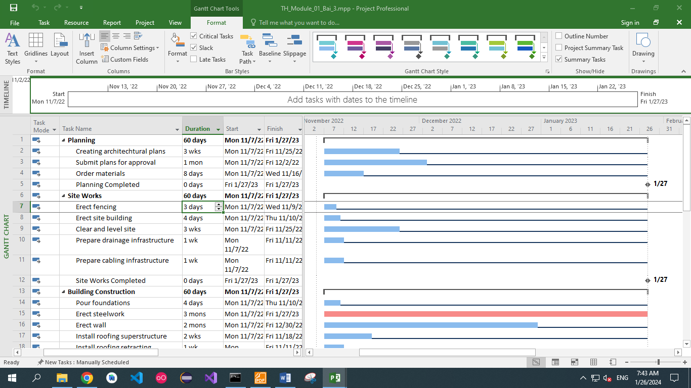

Slack lines in non-critical tasks

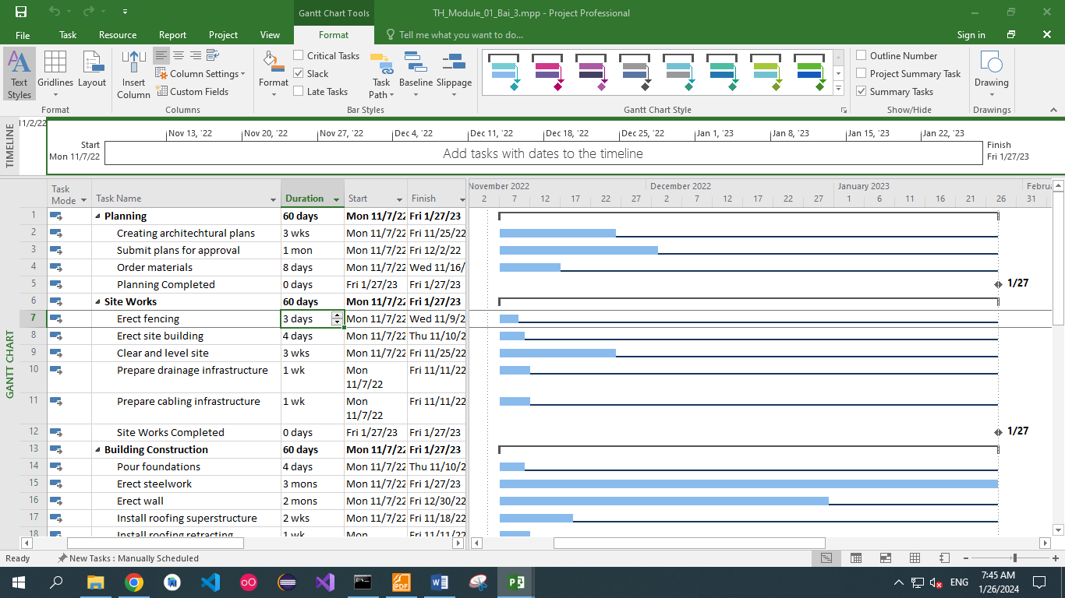

Add column Late Start, Late Finish, Total Slack

